Visual Arts 12 | Module 1 Worksheet

Camera Types

DSLR Cameras (digital single lens reflex) and compact (sometimes called point-and-shoot) cameras are very popular choices today. Both are very capable and effective types of cameras and both can be purchased with very high resolution capabilities. The resolution a camera is capable of is listed in megapixels, or millions of pixels. Each pixel (short for picture element) is a single dot, so the more dots or pixels your picture has, the greater the resolution, and the larger a photo can be printed and still look good.
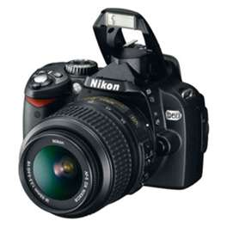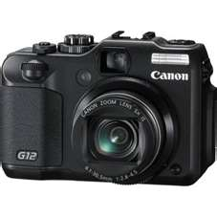

As the above photos indicate both of these types of cameras have similar features such as lenses on the front, built in flash units, command dials on the top along with shutter release buttons, and both could have the same resolution in megapixels. There are however many difference between the two as well. The list below points out some differences.

DSLR Camera | Compact
- Wide range of operations  - Heavy  - Expensive  - Less suitable as a travelling camera  - Wider range of creativity  - Multiple lenses available  - HD video capable  - Complicated menus | - Ease of operation  - Lightweight  - Inexpensive  - Good travelling camera  - Limited creativity  - Single lens available  - HD video capable  - Simplified menus

Menu buttons

All digital cameras have menus which allow photographers to make adjustments for particular shots that auto settings cannot achieve. To access the menu, push the OK or Menu button on either the back or top of camera.

Most DSLR camera menus will indicate the following symbols or something similar. Your camera may look slightly different. Refer to your camera manual for more information.

Playback menu. Used for: viewing, deleting, folders, etc…

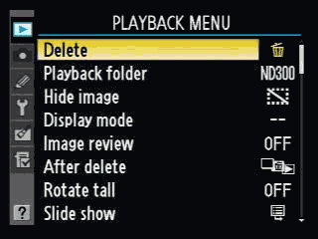

Shooting menu. Used for: image sizing, image quality, white balance and ISO.

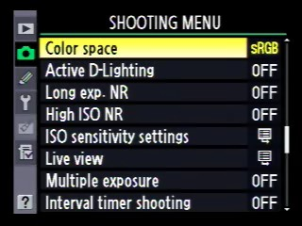

Custom menu. Used for: setting timers, flash timers, etc…

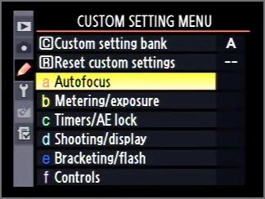

Set up menu. Used for setting time, language, brightness, etc…

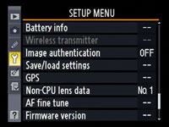

On a point-and-shoot, the menu might be accessible directly from the back of the camera like in the photo below.

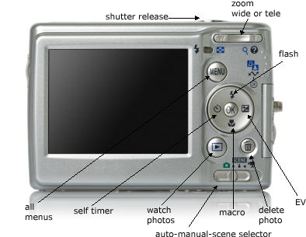

Command dial

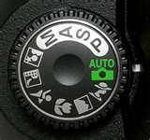

Most DSLR and some point-and-shoot cameras have a command dial located on the top of the camera. This command dial is very useful. Starting at the Auto setting and moving counter clockwise a short description of each will be provided.

- Auto Mode is used to allow the camera to make the all the photographic decisions for the best exposure.
- The Program Mode (P Mode) is essentially a compromise. It automates some settings while you are taking a picture, but lets you have creative control in three important areas: flash, ISO value and white balance.
- S or Shutter priority allows the photographer to choose the speed of the photograph while allowing the camera to select the best aperture (depth of field).
- A or Aperture is used much the same way as S but in this mode the photographer chooses the aperture while the camera selects the correct speed to shoot at.
- M or Manual allows the photographer complete control over all aspects of the photograph.

Moving from Automatic to Manual

Although both DSLR and compact cameras deliver very good results when set to automatic. There is much more creativity and versatility in manual photography. Manual photography is more challenging than using auto because the photographer makes all the decisions regarding speed, focus (aperture) and sensitivity.

- Exposure: Simply means how much light reaches the cameras sensor over a certain period of time.

- Aperture: This is controlled by f-stops, which are numbers that represent how big or small the aperture opening is in the lens of the camera. Think of your own eye. When it is very bright outside your eye's pupil will shrink to a small diameter thereby controlling and reducing the amount of light which enters the eyeball. The opposite occurs when there is low light. As you can see from the picture below, as the f-stop number gets smaller (closer to 1) the aperture gets wider, letting more light in. Conversely, as the f-stop number gets larger (farther away from 1) the aperture gets smaller, letting in less light. All else being equal, a scene shot in bright light conditions will need a larger f-stop (and smaller aperture), while a scene shot in dim light conditions will need a smaller f-stop (and larger aperture).

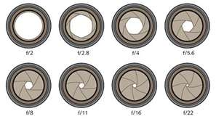

- F stops: These are the numbers on the barrel of the camera or seen in the viewfinder of the camera when set to MANUAL. The concept is really quite simple. The numbers on most cameras will usually be listed as small numbers that increase to larger numbers.

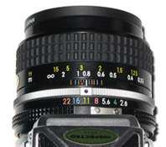

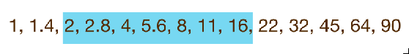

Note the highlighted area is the typical range of "f stops "on most cameras.
- Depth of Field: a term use to describe the amount of an image that is in focus. A photograph that captures everything in sharp focus (everything from the foreground to the farthest background is all in focus) would be said to have a very deep depth of field. A photograph that has a blurred background such as in a portrait would have a very shallow depth of field.

Understanding White Balance (WB) Shooting mode

White Balance is the process of removing unusual color casts, so that objects which appear white in person are recorded as white in your photograph. In digital cameras white balance has to take into account the color temperature. All sources of light have differing temperatures; some are cooler while some are warmer. The human eye is quite good at recognizing what is truly white under different light sources while cameras have difficulty recognizing what is truly white, and this can result in photographs that become unnaturally blue, orange, yellowish and even green.

Incorrect white balance | Correct white balance
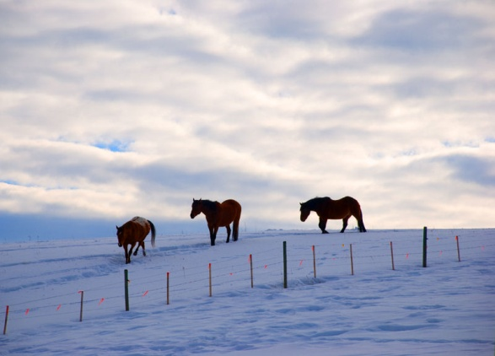 | 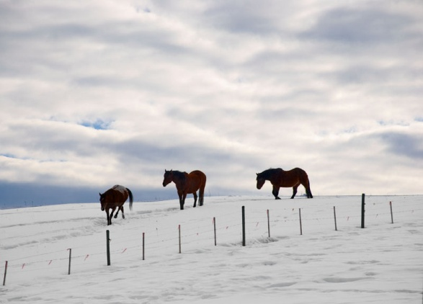
Incorrect white balance | Correct white balance
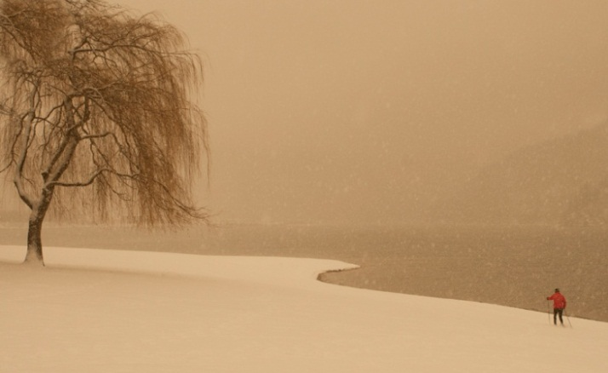 | 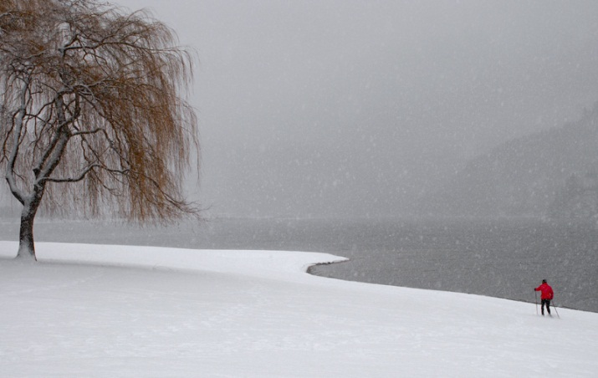

Correcting for white balance

There are a number of ways to correct improper white balance such as auto white balance and preselect options. These will be further explained later in this course.

Menu buttons

Digital cameras have a menu button where a variety of white balance presets can be selected allowing for correct white balance. Push ok/menu – find WB or white balance. Then select:

Tungsten: This setting is used for shooting under incandescent lighting such as a common light bulb

Fluorescent: This setting is best used under florescent lighting.

Daylight: This setting is used in direct sunlight.

Flash: This symbol is used when extra lighting is required such as indoors and for filling in shadows under strong outside light.

Cloudy: This symbol is used for overcast skies.

Shade: This symbol is used when taking photos in shaded conditions.

Automatic White balance: This symbol takes all the guess work out of choosing the right setting. Using AWB tells the camera to choose the correct setting and will take an average of the light conditions and may not always be completely accurate but does work quite well.

Note: There is much more to learn about White Balance such as shooting photographs in "RAW "format and using post production techniques. Please read your camera's manual for further information.

Understanding ISO shooting mode

ISO is an acronym for International Standards Organization. This organization sets and regulates sensitivity options within the photographic industry by assigning numeric values to describe sensitivity levels in digital photography. That is how low-light and bright-light situations are dealt with to make a well balanced and properly exposed photograph. Typically, DSLR cameras and compact cameras allow the photographer to set the sensitivity level to match the light level. In low level light a higher ISO number is selected.

ISO settings will vary from camera to camera and will range from as low as ISO 50 to a very large ISO of 1600 and sometimes more. An increase of 2× from ISO 50 to 100 doubles amount of light reaching camera's processor. A low light situation such as dining by candle light might require an increase to ISO 400 or greater. (a note to keep in mind is that the higher the ISO setting the more pixelated, or grainy, the photo will become.)

ISO 100 | ISO 200
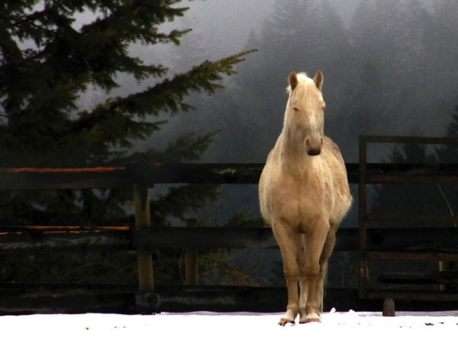 | 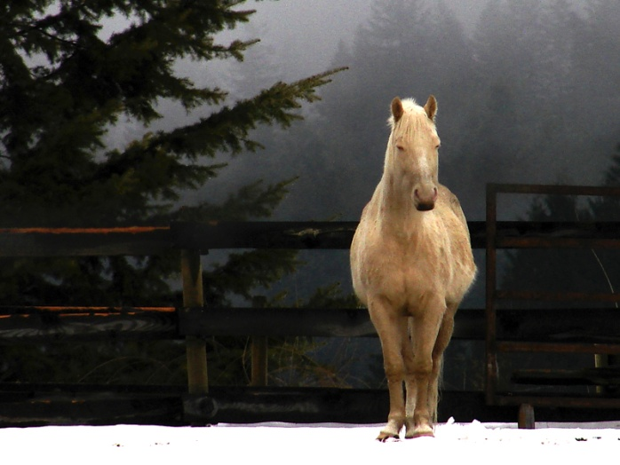

The left photo of the horse was shot at ISO 100 while the bottom was re-taken at ISO 200. The bottom photo setting has allowed twice as much light to strike the processor thereby increasing the sensitivity by two.

In shooting mode, select ISO (sensitivity setting). ISO increments may vary but are usually from a low sensitivity of ISO 50 and can range up to very high sensitivity of as much as ISO 3200. Remember that low light situations require a high ISO (greater sensitivity) and brightly lit scenes require a low ISO selection. On average, ISO 200 is an "every day" setting.

A Shutter is a curtain or diaphragm that opens and closes at various rates of speed which can range from between several seconds and as fast as 1/3000 of a second and faster. The shutter's function is to control how long light is allowed to reach the processor.

Shutter Speed controls the amount of time that light is allowed to strike the image processor. To capture the high-speed movement of a motorcycle race, the shutter speed would have to be very fast, 1/500 second or greater. With subjects that don't move, or move slowly, a slower shutter speed such as 1/125sec or 1/60 sec is adequate to freeze the frame.

High speed shutter  F/5.6 – 1/500 sec – ISO 400 | Slow speed shutter  F/32 – 1/6 sec – ISO 200 with tripod
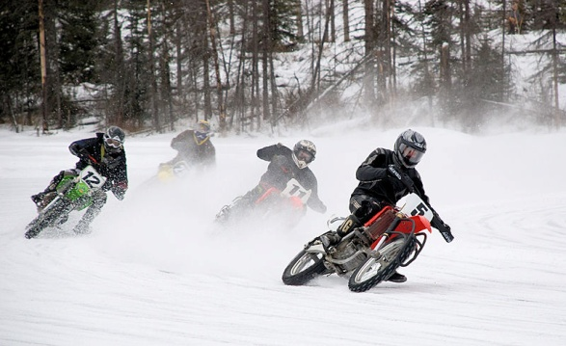 | 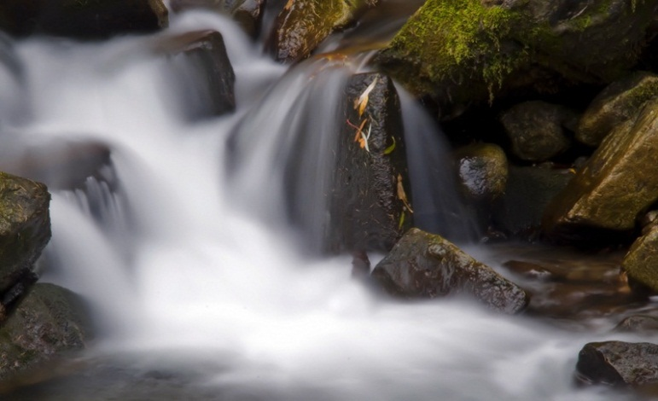

Flash Photography: Most DLSR and Point and Shoot cameras have a built in flash unit and/or a hot shoe attachment for adding separate flash units. Flash is obviously used when under low light situations but there are more ways to use the flash unit. Here are the most commonly applied uses of flash.

- Indoor flash for illuminating a scene at a birthday party, weddings, portraits and night time shots.

- Fill in flash which is used in outdoor bright light situations such as group portraits when the sun is directly in the face of the people being photographed and their faces are darkened by shadows.

- Bounced lighting is used to soften the light on a subject's face especially in portraits. The separate flash unit can be angle to bounce off the ceiling so as to soften the harsh light that flash units can produce.

- Off camera lighting is a technique used with a separate flash unit (DLSR cameras only) that is actually synchronized with the program in the camera which will allow the flash to be placed on the either side of the subject as well as placing it on the floor or other location than on the camera itself.

- Red eye problems can occur with any type of flash and that is because the lens of the camera is lined up directly with a subject's pupil of the eye. One way to avoid red eye is to move the flash away from the lens which cannot be done with a point and shoot camera. But by using the red eye reduction feature this mishap can be avoided.

Here is an example of an off camera flash unit used on a DSLR.

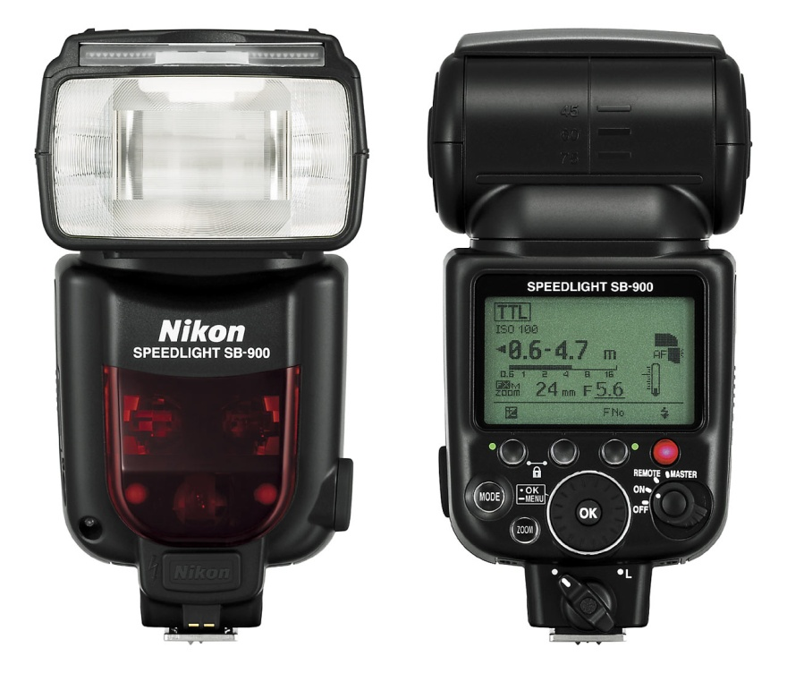

This type of unit attaches to the hot-shoe device located on the top of DLSR cameras, can be manually adjusted for flash output, and can be triggered while off camera.

Compact cameras have built-in flash units and are often output adjustable. The flash on this Olympus camera is just above the Olympus name.

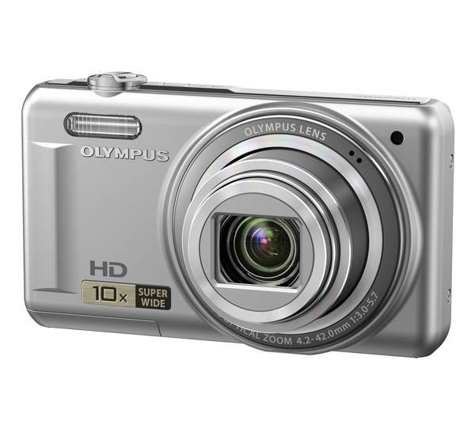

Indoor flash | Fill in flash
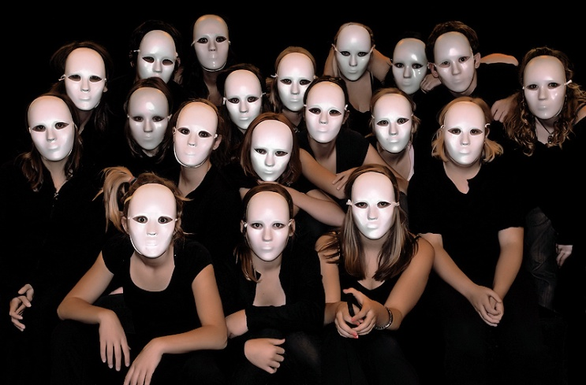 | 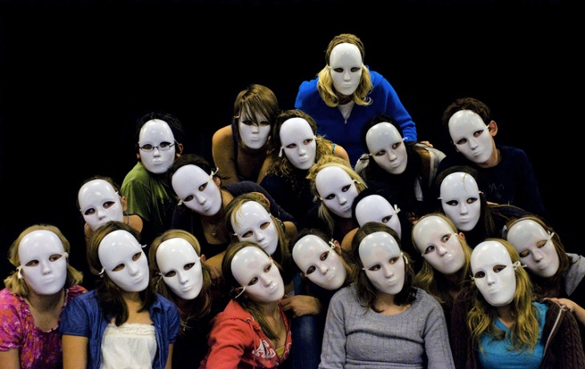

Adjusting shutter speed: Shutter speeds can be adjusted by pushing MENU and selecting "S" or shutter then choose the appropriate speed for the situation. Remember, the faster the action the greater the shutter speed.

Camera Accessories

Shutter Release

A shutter release is an invaluable aid for use with a tripod in order to permit longer exposure times and slower shutter speeds where camera shake could be a problem. Releases are either attached directly to a camera with a cable while others operate remotely. Releases are available for all DSLR cameras and some point and shoot cameras.

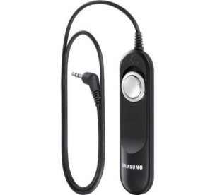

Ultraviolet Filter

The ultraviolet filter cuts ultraviolet light thus helping eliminate haze. More importantly the filter protects the camera's lens from dust and scratches.

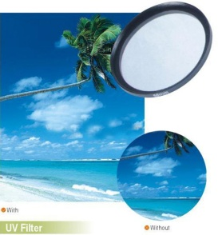

Polarizing Filter

The circular polarizing filter cuts glare from non-metallic surfaces such as water or glass. The filter also produces dramatic and darker blue skies when used at angles 90 degrees from the sun.

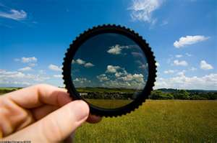

Use of a tripod

A steady camera is a necessity for all types of photography so in any situation they will be useful. Use a tripod when you take night time photos and sunsets. A camera will adjust exposure and shutter speed when set to the Night setting. However, with a slower shutter speed, there is the risk of camera shake which results in unwanted blurring. A tripod will reduce camera movement and improves picture quality, helping you take the perfect sunrise or sunset.

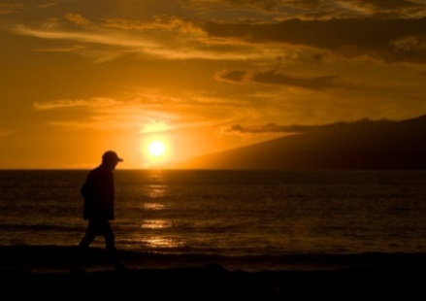

Use a tripod when you are taking close up photos. It will noticeably reduce unwanted movement of the camera.

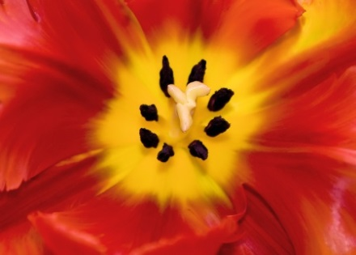

Use a tripod when you are taking action photos and doing sport photography.

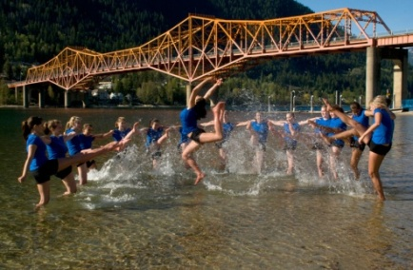

Use a tripod when you are doing nature photography. It is a key in getting great nature photos as you can be waiting around for hours for animals to make an appearance that might only last a few seconds

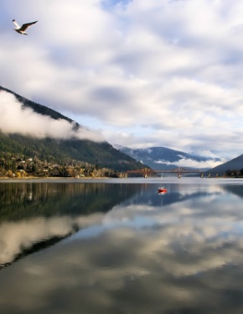

A good tripod will help steady your camera and ensure sharp photos. Many tripods have the ability to let you place the camera anywhere from just inches off the ground to way above eye level.

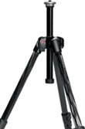

How to download your photos

Digital cameras can be directly connected to a computer with a USB cable. You can also remove the memory card and insert it into a card reader built in to your computer, or attached to your computer via a USB cable.
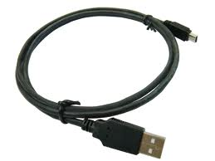 | 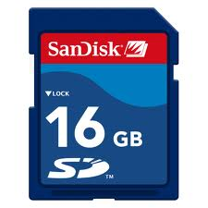

Downloading Using Windows 7
1. Connect the camera to the computer. You will need the camera's cable. Turn on the camera after you connect it. Windows' "Auto Play" dialog box will appear, showing a list of options. | 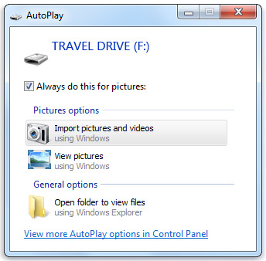
2. Select "Import pictures and videos using Windows." The "import" dialog box opens. | 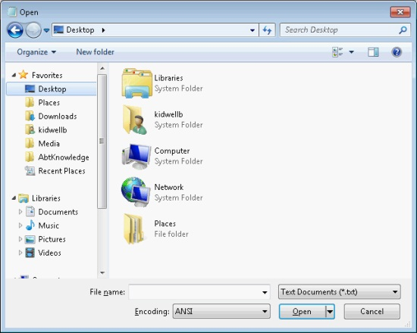

3. Enter a tag or a title for the pictures that are about to be imported.

4. Click "Import or next." Windows 7 will copy the pictures from the camera to the computer. When the importing is completed, the pictures' destination folder will open in a new window. | 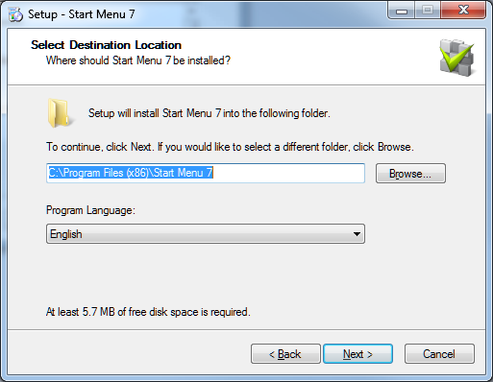

Resize images

Photos taken with digital cameras can be very large. While this is desirable if you wish to print the photo, it can be a problem if you want to share the photo via email or on a web page.

To resize a photo in Photoshop, with an image loaded, go to Image | Image size

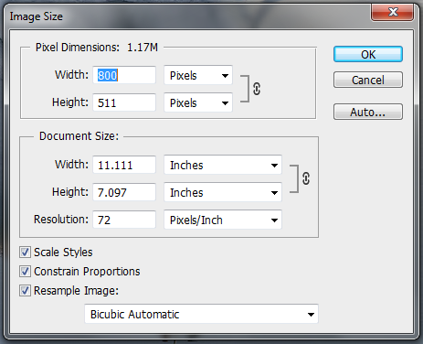

By changing the numbers for width and height to a smaller number, you won't lose much in the way of image quality. However, you will absolutely lose image quality if you try to make your image larger.

The best way to send pictures by email is to send them as JPEGs, a picture format nearly every computer can open. Pictures saved as JPEG will have a .jpeg or .jpg file extension. A width of 800 on the long side is usually perfect, like this one below. To change size when previewing the photo in Windows Photo Viewer, click on the E-Mail menu, then choose Small: 800 × 600.

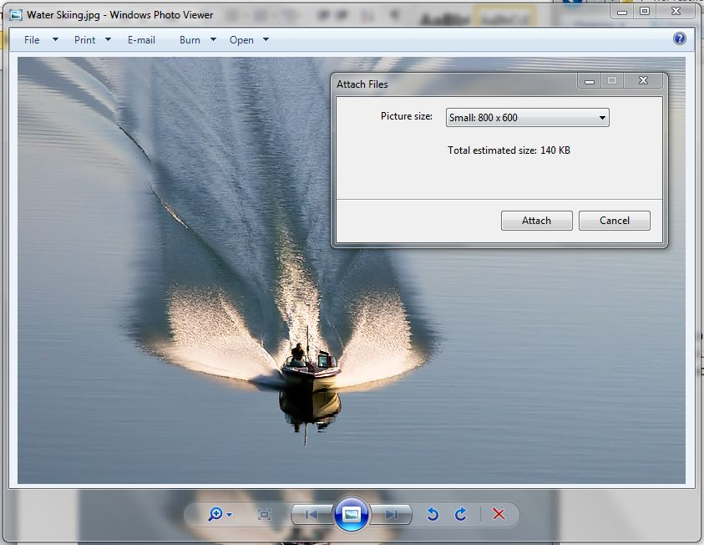

Glossary

Aperture: A circular opening in a lens which controls the amount of light reaching a camera’s film or sensor.

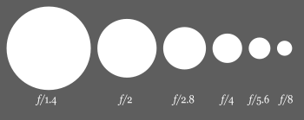

These are standard aperture openings called f stops and as the number increases less light is allowed through the lens. A smaller opening allows a greater depth of field. Modern cameras automatically set aperture values but in manual mode an understanding of aperture settings is important.

Brightness/Contrast: A measurement that indicates the distinction in luminance (brightness) from the darkest area of a picture to the lightest area.

Clone stamp tool: This Photoshop tool is used to cover parts of a photo not wanted by taking one part of the photo and placing it over another.

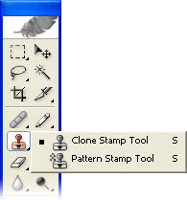

Filters: Camera accessories consisting of optical filters inserted in front of a lens allowing various effects. Common filters are polarizers and neutral density filters.

Command dial: Allows switching pre-program modes. These modes include automatic, manual, aperture priority, shutter priority and so on.

Depth of Field: A term use to describe the area of an image that is in sharp focus.

Exposure: The amount of light reaching a camera sensor over a certain period of time.

F stops: A number representing the aperture opening of a lens.

Framing: Refers to the central object of interest being outlined or “framed” by other parts of the image.

Horizon Line: The horizon is the apparent line that separates earth from sky.

ISO: An acronym for International Standards Organization which regulates sensitivity options within the photographic industry. A higher ISO number permits faster shutter speeds and smaller apertures, but the higher the number the greater the degradation of the photographic image. In regular photographic shooting, lower numbers are desirable for a higher quality image. Higher numbers are used generally for images taken in low light or where faster shutter speeds are required.

Leading lines: This is an especially powerful technique to draw the viewer's attention to one or more intended subjects or to a single focal point.

Rule of Thirds: A guideline for photographic composition based on the theory that human perception will find an image to be more interesting if the subject is located around the points 1/3 of the way across the image, either (or both) horizontally and vertically.

Shutter speed: A common term used to discuss exposure time, the effective length of time a camera's shutter is open. Faster shutter speeds are used to freeze action, as in sports photos, where much movement is a part.

Triangulation: Used to highlight and to isolate three primary points of interest by placing each on one of the triangle’s points.

Variations: A Photoshop tool used to increase or decrease the level of color saturation in a photo or in only parts of it.

White balance: The process of removing unusual color casts, so that objects which appear white in person are recorded as white in your photograph.

Selection tools: Changes such as sharpening, color saturation or brightness can be made to affect an entire photograph or to just certain parts. Photoshop has a number of selection tools available.

The Magic Wand Tool: Resembling a wand, this tool can be found in Photoshop’s tool bar near the top. After clicking on an area, the wand selects other pixels of the same or similar color. Along the task bar at the top, two settings are important. Set threshold to 30 to begin and set contiguous for a selection only of adjoining colors. After the selection is satisfactory, changes such as sharpening can be made which will apply only to the area selected. In all cases this tool can be repeated until all desired areas are selected.

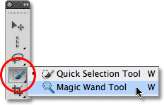

The Polygon Tool: The polygon selection tool draws a straight line in segments in any direction while clicking along the path chosen. When the path is complete and the starting point is reached, double click at that point and the selection is complete.

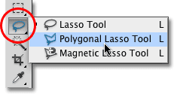

The Lasso Tool: Similar to the polygon tool but more a free form tool which allows a selection to be made in all directions.

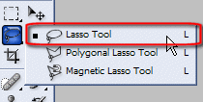

Other selection tools are also available including the rectangular and elliptical marquee tools used to create rectangular, square, round or elliptical selections.

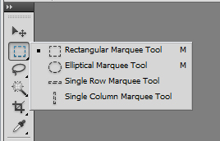

More details and instructions for use can always be found in the help section in Photoshop.

The Tool Box:

