Name:
Personalized Inquiry Plan for Developing our Profession
**Based on: Spiral of Inquiry Model
Linda Kaiser and Judy Halbert, Leadership Mindsets, 2009
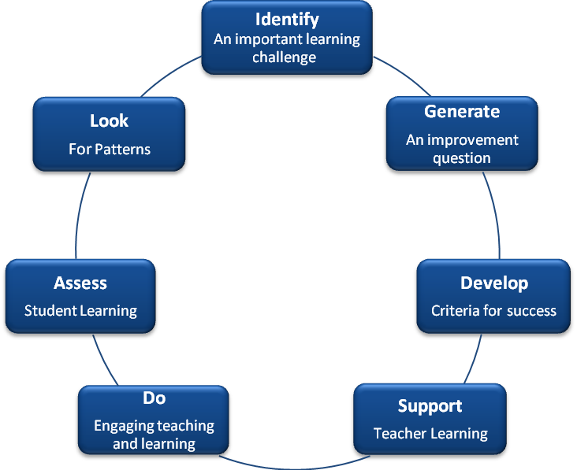

Subject Area and/or Grade:
Identify: (What challenges are you noticing about learing in your class; what are the students challenged by, what are you challenged by?)

Improvement question: (Frame the learning challenge as a question that could enable you to develop an action orientated plan that could move learning forward.)

Develop: (What might you notice happening for your learners and you as their teacher? How will you know that you are closing the gap between knowing and doing?)

Support: (What I might need to explore the inquiry further?) My learning partner(s):

Do: (My action plan)

Assess: (What are the formative and summative assessment strategies that I may use to support this inquiry?)

Look: (What other information could you look at that might indicate patterns and trends in learning?)

Other Important Information:

